# CP1406 - 2017 Project Plan

**Members:** S. Saad Mohsin, Tiffany Teo Shao Min

## Mission

## Our mission is to be recruiting of new members to join the club. Increasing of engagement of members in our events or activities held. For instance, volunteering in organising events or even endorsing our workshops to let us be more known to the public. Moreover, to increase of ticket sales to the public. Urge the performers to let us manage their concert and encourage them to accommodate with promotion, photo shootings.

## Success Evaluation

The number of events undertaken by the music club like promotions, photo shoots, media releases, etc.

## Target Audience

We provide performance opportunities for a very wide range of style and categories which otherwise have little exposure, therefore our **target audience** includes a wide range of ages be it elderly, young adults or children. However, if children below 18 are involved, parents or family members must lead them along. Every concert, therefore need a peculiar theme. If every concert has the same theme, it would be monotonous. Hence, different theme would lighten up the atmosphere.

## Content

...

## Site Flowchart (Structure Diagram)

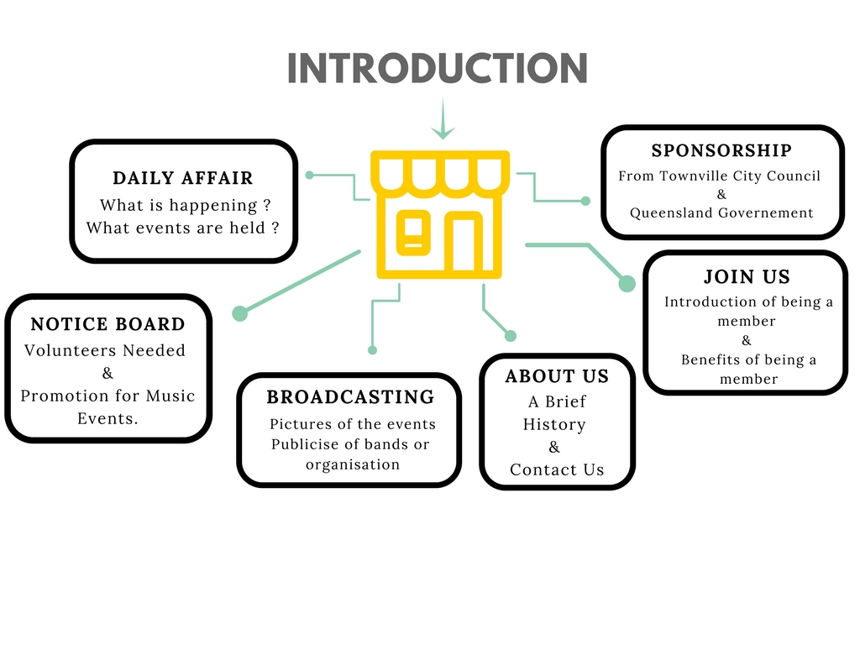

## GitHub Repository

<https://github.com/tshaomin/CP1406-Group-Website-Assignment-2>

## Comps

provide links here to your 3 comps (images or HTML pages)

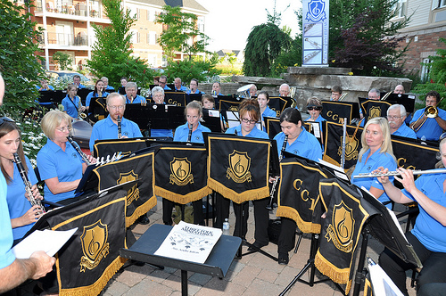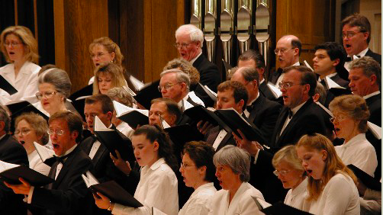

Html Pages:

1. Introduction.html (Done)
2. Home.html
3. Aboutus.html
4. Joinus.html
5. DailyAffair.html
6. Noticeboard.html
7. Broadcasting.html
8. Sponosrship.html

## Developed Page

Desktop/A2/Introduction.html